Mary Elizabeth (Cleaves) Tabler
May 27, 1848 – May 12, 1918

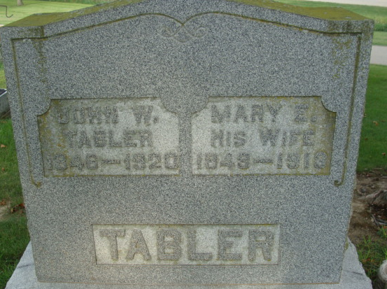
Photo by Alicia Kneuss

ILL SHORT TIME
Mary E. Tabler, Well Known Lady of Monroe Township
ILL DAY OF PARALYSIS

Mary E. Tabler, 71, well known aged lady of Monroe Township, wife of John W. Tabler, died there Sunday afternoon at two o'clock after a days' illness of paralysis.
She was born November 15, 1847 [sic], being a daughter of Israel and Harriet Cleaves and for the past thirty-five years has resided a half-mile west of Monroe.
Surviving children are Hazel Tabler, Jamestown, N. D.; Clara Mumma, Union Township; Ferdinand H. Tabler, Charity J. Martz, of Monroe. Scott and Edward Cleaves, brothers, live in Ohio.
The funeral will be Wednesday afternoon at 1:30 o'clock from the Monroe Methodist Church. Rev. Mr. Krider will be in charge and burial will be in the Decatur Cemetery.

Decatur Daily Democrat, Adams County, Indiana
Monday, May 13, 1918

**
Indiana, Death Certificates, 1899-2011
Name: Mary Elizabeth Tabler
[Mary Elizabeth Clever]
Gender: Female
Race: White
Age: 70
Marital status: Married
Birth Date: 27 May 1847 [sic]
Birth Place: Orange Co Ohio
Death Date: 12 May 1918
Death Place: Washington, Adams, Indiana, USA
Father: Ezra Cleaves
Mother: Hannah Gillmore
Spouse: John W. Tabler
Informant: H. F. Tabler; Monroe, Indiana
Burial: May 14, 1918; Decatur Cemetery

