Mary R. (LaBrun) Tabler-Martz
June 24, 1884 – November 5, 1974

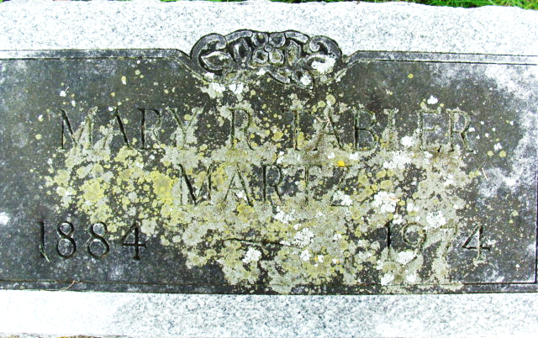
Photo by Alicia Kneuss

MARY MARTZ DIES TODAY AT AGE 90
Mary R. Martz, 90, a former Monroe resident, died at 3:25 a.m. today at the Adams County Memorial Hospital, where she had been a patient since October 16. She had been a resident of the Decatur Community Care Center since November of 1968.
Born to Ezra and Martha Rice LaBrun on June 24, 1884 in French township, she was first married to Fred (sic - Ferdinand) Tabler, who preceded her in death on August 21, 1934. She married E. Coy Martz in 1940 and his death occurred in 1968.
Mrs. Martz was co-owner of the Tabler Grocery Store and the Martz Grocery Store in Monroe for many years, selling the business in 1968 just before the accidental death of Mr. Martz.
A member of the Monroe United Methodist Church, she is survived by two stepdaughters, Mrs. Henry (Hester) Wyss of Fort Wayne, and Mrs. Leo (Bessie) Teeple of route 6, Decatur; and one stepson, Edward Martz of Fort Wayne. Also surviving are one grandson, Jack Moore of Tucson, Arizona, and two great-granddaughters.
One daughter, Mrs. Blanche Tabler Moore, and two sisters, Sadie Essex and Minnie Coppess, preceded her in death.
Funeral services, with Rev. Donald E. Wilks in charge, will be held at 2 p.m. Thursday at the Zwick Funeral Home, and friends may call after 2 p.m. Wednesday. Burial will be in the Decatur Cemetery.
Decatur Daily Democrat, Adams County, Indiana
Tuesday, November 5, 1974

