John Williams Tabler
September 20, 1846 – April 30, 1920

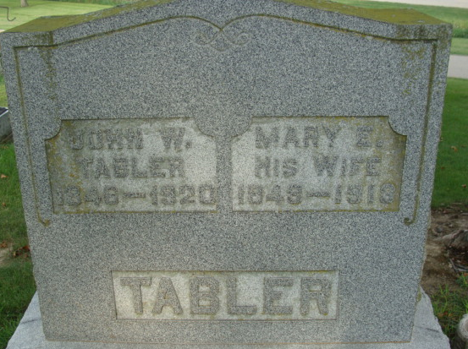
Photo by Alicia Kneuss

J. W. TABLER DEAD
Well Known Monroe Resident Answers Call at an Early Hour Today
FUNERAL SUNDAY
Was Seventy-Three Years Old - A Resident of Indiana Forty-two Years

John W. Tabler, well known resident of the county, died at 2:15 this morning at the home of his daughter, Mrs. Charity Martz, one mile south and one and one-half miles east of Monroe. A complication of diseases was the cause of his death.
Mr. Tabler was born in Auglaize County, September 20, 1846, the son of Thomas Jefferson Tabler. He came to this county forty-two years ago and has resided in Adams County many years, living in Washington Township most of the time. For the past few years, however, he has lived at Monroe and was at the home of his daughter temporarily when the final summons came. The wife died two years ago.
Surviving are three children, Mrs. C. S. Mumma of Union Township, Mrs. Charity Martz of Monroe and Marion H. Tabler of Decatur.
Funeral services will be held Sunday afternoon leaving the house at 1:30 o'clock, and from the Monroe M. E. Church at 2 o'clock. By request of Mr. Tabler, the Rev. Phillips of Monroeville will officiate at the service, assisted by the Rev. Krider of Monroe.

Decatur Daily Democrat, Adams County, Indiana
Friday, April 30, 1920

**
Indiana, Death Certificates, 1899-2011
Name: John Williams Tabler
Gender: Male
Race: White
Age: 7? years, 7 months, 10 days
Marital status: Widowed
Birth Date: 20 Sept. 184??
Birth Place: Anglaiz Co Ohio
Death Date: 30 Apr 1920
Death Place: Monroe, Adams, Indiana, USA
Father: Thomas Jefferson Tabler
Mother: ??ne Gillmore
Spouse: Mary Elizabeth Cleaves
Informant: Frank Martz; Monroe, Indiana
Burial: May 2, 1920; Decatur Cemetery

