Ferdinand H. Tabler
September 7, 1876 – August 21, 1934

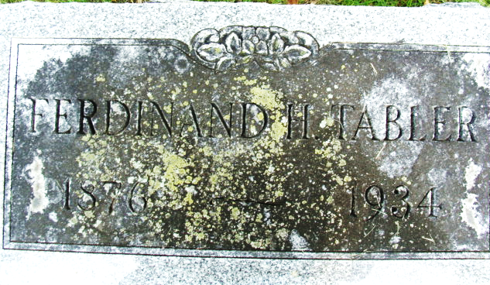
Photo by Alicia Kneuss

Handwritten: Thursday, Aug. 23, 1934
DEATH TAKES FERD TABLER
Prominent Monroe Businessman is Victim of Infection
Ferdinand H. Tabler, 57, well-known Monroe business man, died at the Adams County Memorial Hospital in Decatur Tuesday afternoon at 1:40 o'clock. Death resulted from blood poison which developed from an infection on his right hand. Mr. Tabler was one of Monroe's leading business men and the town will feel his loss to a great extent.
Mr. Tabler had injured his hand several weeks ago while working at his filling station at Monroe. An infection developed and he was removed to the hospital last Friday.
Mr. Tabler had resided in Monroe for about 30 years. He conducted a garage at Monroe for a number of years, later going into the grocery and restaurant business. Several years ago he opened a filling station.
He was born in Ohio on September 7, 1876, a son of John and Mary Tabler. His marriage to Mary LeBrun took place in Monroe and one daughter was born to the union, Mrs. Blanche Moore of Ft. Wayne.
Surviving besides the widow and daughter, are a grandson, Jack Moore of Ft. Wayne, a brother, M. H. Tabler of Maywood, New Jersey; and two sisters, Mrs. C. S. Mumma of Markle and Mrs. Frank Martz, of Monroe.
He was a member of the Methodist Church of Monroe.
**
Handwritten: Thursday, Aug. 23, 1934
TABLER FUNERAL TODAY
Funeral services for Ferd Tabler, well-known Monroe businessman who died Tuesday, were held this afternoon at 1:15 o'clock at home and at 1:30 at the Monroe M. E. Church, Rev. Elbert Morford, pastor of the church officiating. Burial was made in the Decatur Cemetery.

Adams County (IN) Historical Museum
1934 Scrapbook, image 076

