Lemuel Louis Syphers
February 28, 1866 – March 20, 1933

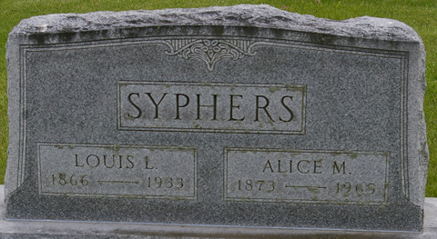
Photos by Corgilover

Funeral services for Lemuel Louis Syphers, aged 67, who died Monday, will be held Thursday at 10 am at Klaehn & Sons Funeral Home with Dr. Ernest C. Wareing officiating. Burial will be in Maplewood Cemetery at Decatur. The Rev. Mae Hibbs, pastor of the First National Spiritualist Church will conduct services at the funeral parlors tonight at 7 o’clock.

News-Sentinel, Allen County, Indiana
March 22, 1933

**
Indiana, U.S., Death Certificates, 1899-2017
Name Lemuel Louis Syphers
Gender Male
Race White
Marital Status Married
Age 67
Birth Date 28 Feb 1866
Birth Place Salem, Indiana
Death Date 20 Mar 1933
Death Place Fort Wayne, Allen, Indiana, USA
Death Registration Date 1933
Father William Syphers
Mother Elizabeth Fisher
Spouse Alice
Informant Alice Syphers
Burial March 23, 1933; Decatur, Indiana

