Alice M. (Fisher) Syphers
February 16, 1873 – February 28, 1965

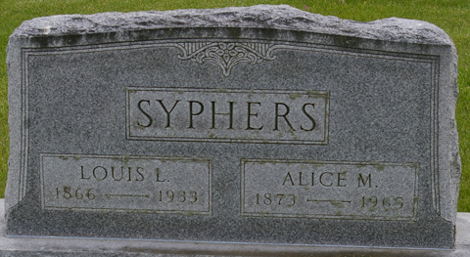
Photos by Corgilover

Alice Syphers
in the Indiana, U.S., Death Certificates, 1899-2017

Name Alice Syphers
[Alice Fisher]
Gender Female
Race White
Age 91
Birth Date 16 Feb 1873
Birth Place Decatur, Indiana
Death Date 28 Feb 1965
Death Place Fort Wayne, Allen, Indiana, USA
Death Registration Date 1965
Father Thomas Fisher
Mother Ruth Mallonee
Informant Mrs. Ruth Lee; daughter; Fort Wayne, Indiana
Burial March 2, 1965; Maplewood Cemetery; Decatur, Indiana

