Virginia A. (Waterman) Swygart
September 20, 1923 – January 14, 2013

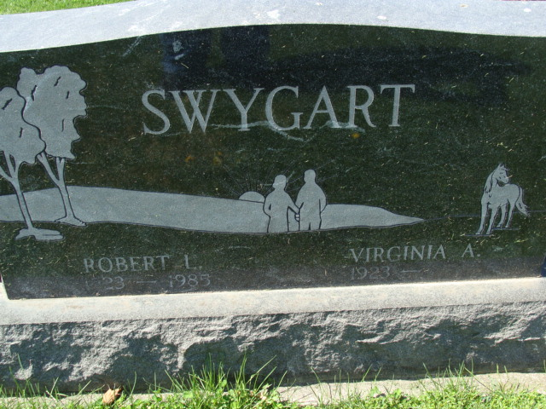
Photo by Alicia Kneuss

Virginia A. Swygart, 89 years old of Decatur, Indiana, passed away at 11:10 a.m. on Monday, January 14, 2013 in the Woodcrest Nursing Center located in Decatur. Virginia was born on Thursday, September 20, 1923 in Dixon, Indiana the daughter of the late Charles Waterman and the late Samantha (Murchland) Waterman. She married the late Robert L. Swygart Sr. on March 21, 1942 in Ft. Wayne, Indiana and he passed away on May 23, 1985.
Virginia was a homemaker and had been the owner & operator of High Street Bar in Montpelier, Indiana for 33 years.
Surviving are her son, Robert L. (Janice) Swygart Jr. of Decatur, IN; daughter, Sandra S. (Gene) McKean of Decatur, IN; daughter, Patricia A. (Don) Kriegel of Decatur, IN; 12 grandchildren: Laura Clough, Mark McKean, Michael Swygart, Eliza Erxleben, Erin Heyerly, John Kriegel, Elizabeth "Betsy" Kriegel, Scott Young, Anthony Swygart, Christopher Swygart, Joseph Swygart, & Jeremy Swygart; 12 great-grandchildren: Kayla Boots, Laurell Clough, Samuel McKean, Adam Swygart, Aaron "AJ" Swygart, Zachary Swygart, Trevor Swygart, Lorenz Conrad, Alivia Reinhart, Adrianna Kriegel, Luke Heyerly, Jenna Heyerly; 1 great-great-grandson: Jaden Boots.
Preceding Virginia in death were 1 son, Thomas Swygart; 1 grandson, Robert G. Swygart; 3 brothers, Byron, Marvin, & Charles Waterman; 1 sister, Barbara McIntosh.
Funeral services will be held at 10:30 a.m. Friday, January 18, 2013 in the Zwick & Jahn Funeral Home with Rev. Steve Waterman and Chaplain John Follett officiating. Interment will follow in the Decatur Cemetery. Friends will be received from 9:30 a.m. to 10:30 a.m. Thursday, January 17, 2013 at the Woodcrest Porter Auditorium and from 3-5 and 6-8 p.m. at the Zwick & Jahn Funeral Home, Decatur, IN and also one hour prior to services Friday at the funeral home. Preferred memorials are to Family LifeCare-Berne or donor's choice.

Zwick & Jahn Funeral Home, Adams County, Indiana

