Thomas Gale Swygart
March 1, 1948 – June 7, 1979

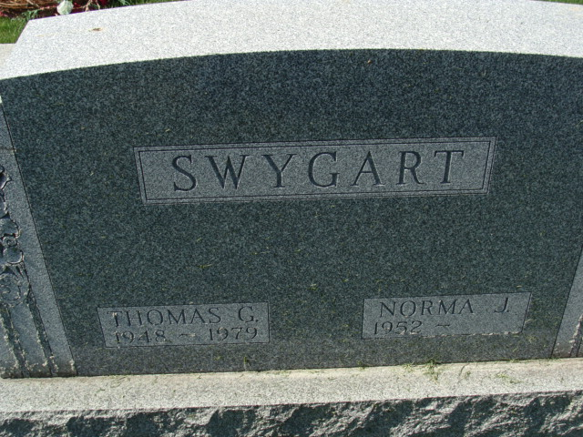
Photo by Alicia Kneuss

Thomas Gale Swygart
in the Indiana, U.S., Death Certificates, 1899-2017

Name Thomas Gale Swygart
Gender Male
Race White
Marital Status Married
Age 31
Birth Date 1 Mar 1948
Birth Place Indiana
Death Date 7 Jun 1979; auto/motorcyle accident
Death Place Fort Wayne, Allen, Indiana, USA
Death Registration Date 1979
Father Robert L Swygart
Mother Virginia A Waterman
Spouse Norma Plank
Informant Mrs. Norma Swygart; Bluffton, Indiana
Burial June 10, 1979; Decatur Cemetery; Decatur, Indiana

