Robert Lyle Swygart Sr.
May 3, 1923 – May25, 1985

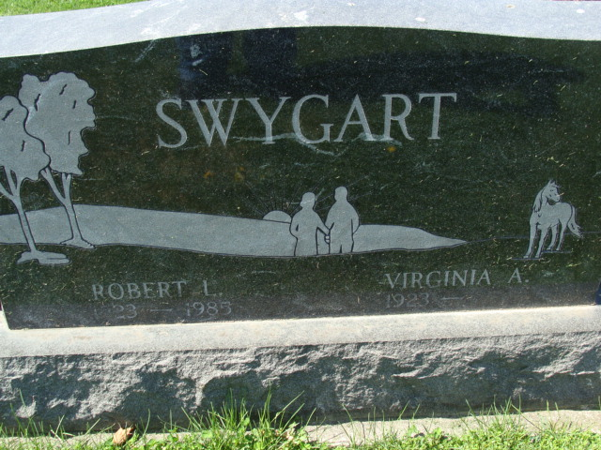
Photo by Alicia Kneuss

Robert Lyle Swygart Sr
in the Indiana, U.S., Death Certificates, 1899-2017

Name Robert Lyle Swygart Sr
Gender Male
Race White
Marital Status Married
Age 62
Birth Date 3 May 1923
Birth Place Indiana
Death Date 25 May 1985
Death Place Bluffton, Wells Co in, Indiana, USA
Death Registration Date 1985
Father Lafe Swygart
Mother Leah Dibble
Spouse Virginia Waterman
Informant Virginia Swygart; Montpelier, Indiana
Burial May 28, 1985; Decatur Cemetery; Decatur, Indiana

