Richard Swygart Jr.
November 6, 1947 – February 28, 1948

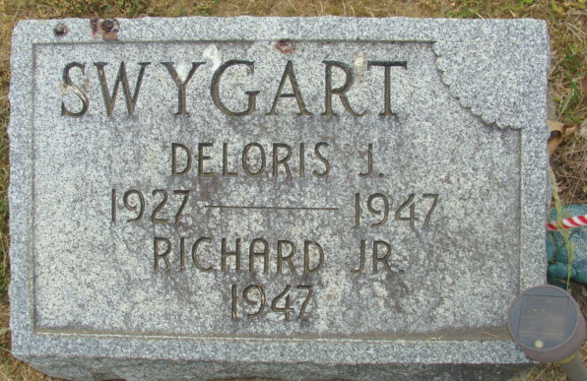
Photos by Alicia Kneuss

CHILD SUFFOCATES IN CRIB SATURDAY
RITES HELD AT DECATUR TODAY FOR INFANT; MOTHER DIED AT CHILD'S BIRTH

Funeral services were conducted at 1 p.m. today at the Gillig and Doan Funeral Home in Decatur for Richard J. Swygart, infant son of Richard D. Swygart, of Decatur, who was found dead in his crib of suffocation. The child was found at 9:00 a.m. Saturday. The tot had apparently pulled the blanket around his head, shutting off the air and had been dead for some time when found.
The child was born last November 8. The tot's mother, died shortly after the child's birth.
Surviving besides the father are a brother, David, and the grand-parents, Mr. and Mrs. Lafa Swygart and Henry Clark, all of Decatur.
The Rev. C. A. Eddy officiated at the rites today and burial was in the Decatur Cemetery.

Adams County, Indiana Historical Museum
1947Dec-Apr1948 Scrapbook, image 36
Handwritten-Monday, March 1, 1948
**

Indiana Death Certificates

Richard J. Swygart
Gender: Male
Race: White
Age: 3 months, 20 days
Marital Status: Baby
Birth Date: 6 Nov 1947; Birth Place: Decatur, Indiana
Death Date: 28 Feb 1948; suffocated in crib
Death Place: Decatur, Adams, Indiana, USA
Father: Richard D Swygart
Mother: Deloris Clark
Informant: Dale Swygart, Decatur, Indiana
Burial: March 1, 1948, Decatur Cemetery; Decatur, Indiana

