Paul Edward Swygart, Sr.
September 29, 1935 – March 12, 2006

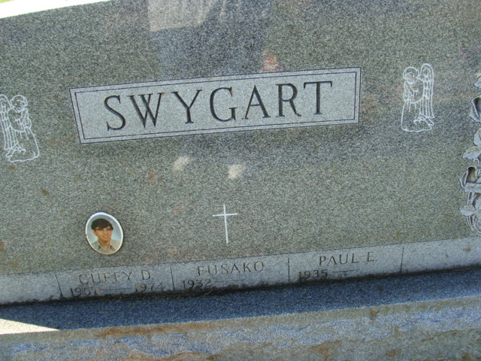
Photo by Alicia Kneuss

Paul E. Swygart Sr.
in the U.S., Obituary Collection, 1930-Current
Name Paul E. Swygart Sr.
Gender Male
Death Age 70
Birth Date 29 Sep 1935
Birth Place Decatur, Ind.
Residence Place Bypass Road, WELLS
Death Date 12 Mar 2006
Death Place Wells
Obituary Date 17 Mar 2006
Obituary Place Augusta, Columbia, South Carolina, USA
Father Lafeyette Swygart
Mother Leah Swygart
Spouse Judy S. Stutes
Child Francela Ripley, Serena Allen, Cuffy Swygart, Darryn C. Stutes, Paul E. Swygart
Siblings Lafe Swygart, Gerald Swygart, Richard Swygart

**
Paul Edward (Bud) Swygart from tree Swygart Family Tree
Birth 29 Sep 1935 Decatur, Adams, Indiana, USA
Marriage 2 Mar 1956
Residence 2008 Wells, York, Maine, USA
Death 12 Mar 2006 Wells, York, Maine, USA
Father Lafe Swygart (1890-1978)
Mother Leah Agnes Dibble (1896-1949)

