Norma Jean (Plank) Swygart
1952 -

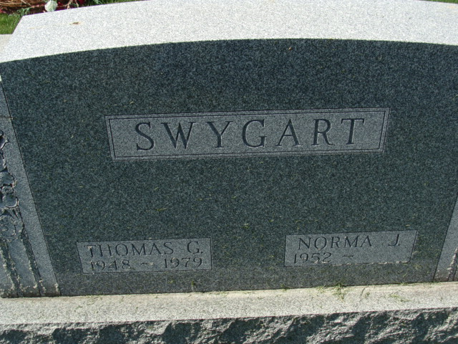
Photo by Alicia Kneuss

Norma Jean Plank
in the Web: Indiana, U.S., Marion Public Library Marriage Index, 1831-2008

Name Norma Jean Plank
Gender Female
Marriage Date 10 Oct 1970
Marriage Place Grant, Indiana, USA
Spouse Thomas Gale Swygart
**

Indiana, U.S., Marriage Certificates, 1960-2012

Name Norma Jean Swygart
[Norma Jean Plank]
Gender Female
Race White
Marriage Age 53
Birth Date abt 1953
Marriage Date 3 Jun 2006
Marriage Place DeWitt, Grant, Indiana, USA
Marriage Registration Date 2006
Father Joseph Russell Plank
Mother Myrtle Cora Justice
Spouse Richard Lee Hart

