Mary (Spuhler) Swygart
June 23, 1871 – July 27, 1964

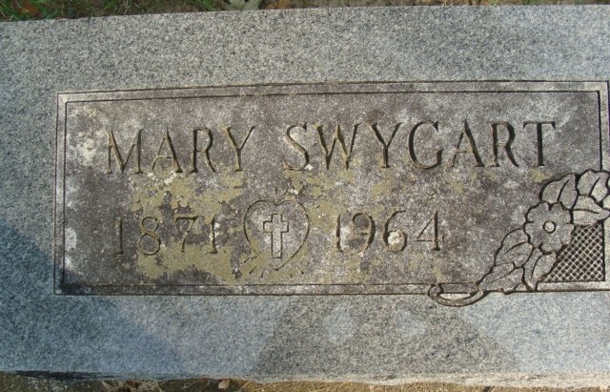
Photo by Alicia Kneuss

Collection: Indiana Marriages, 1811-1959

Groom: James Sherman Swygart/James Swigart
Groom's Race: White
Groom's Date of Birth: 09 May 1858; Place of Birth: Van Wert, Van Wert, Ohio
Groom's Residence: Decatur, , Indiana
Groom's Number of Marriage: 2
Groom's Father: Jery/Jerry Swigart
Groom's Mother: Mary Kniferd/Kiferd
Bride: Mary Shaw
Bride's Race: White
Bride's Date of Birth: 23 Jun 1871; Place of Birth: , , Germany/Indiana
Bride's Residence: Decatur, , Indiana
Bride's Number of Marriage: 2
Bride's Father: John Spuhler
Bride's Mother: Barbara Bloom
Date of Marriage: 11 Jun 1914; Place of Marriage: Decatur, ,
Record Number: 466; GSU Film Number: 2321468; Digital GS Number: 4186023; Digital Image Number: 00425; Number of Images: 1
Record Number: 4591; GSU Film Number: 2321469; Digital GS Number: 4186024; Digital Image Number: 00301; Number of Images: 1

**
Mary SPUHLER from tree Jeff and Becky's Family Tree

Birth Apr 1871 Switzerland
Marriage 11 Jun 1914 Decatur, Adams, Indiana, USA
Residence 1 Apr 1950 Decatur, Adams, Indiana, USA
Death 27 Jul 1964 Fremont, Sandusky, Ohio, USA
Father John SPUHLER (Born 1845)
Mother Barbara BLOON (1842-1929)
Spouse Harvey Alexander Shaw (1867-1945)
Spouse James SWYGART (Born 1858)

