Marcyle M. (Geimer) Swygart
August 5, 1931 – January 18, 2000

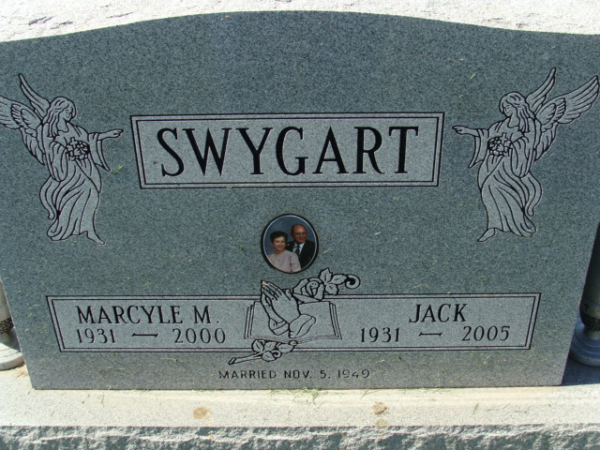
Photo by Alicia Kneuss

Marcyle M. Swygart, 68, of New Haven, a native of Decatur, died Tuesday, Jan. 18, 2000, at home. She was a homemaker, lived in Monroeville and Elkhart and was a member of St. John the Baptist Catholic Church.
Surviving are her husband, Jack; sons William I. of Hoagland, John E. and Stephen J., both of Monroeville, Kenneth W. of Plymouth, Daniel L. of Decatur and Michael L. of Wakarusa; a brother, Edward C. Geimer of Japan; sisters Esther C. Braun and Helen J. Meyer, both of Decatur, and Naomi Lengerich of Dayton, Ohio; and 19 grandchildren. She was preceded in death by a brother, Francis Geimer.
Prayer services at 9:30 a.m. Friday at Haggard & Sefton Funeral Home, Decatur, precede Mass of Christian Burial at 10 a.m. Friday at St. Mary of the Assumption Catholic Church, Decatur. Calling is from 2 to 4 and 6 to 8 p.m. today with a 3:30 p.m. rosary service at the funeral home. Burial will be in Decatur Cemetery.
Memorials are to the Heart Foundation or Kidney Foundation.
Information provided by Haggard and Sefton Funeral Home, Decatur, 1-219-724-7167.

News-Sentinel, The (Allen County, Indiana)
Thursday, January 20, 2000
**

Indiana, U.S., Death Certificates, 1899-2017

Name Marcyle M. Swygart
[Marcyle M. Geimer]
Gender Female
Race White
Marital Status Married
Age 68
Birth Date 5 Aug 1931
Birth Place Decatur, Indiana
Death Date 18 Jan 2000
Death Place New Haven, Allen, Indiana, USA
Death Registration Date 2000
Father Florian Geimer
Mother Bertha Ulman
Spouse Jack Swygart
Informant Jack Swygart; husband; New Haven, Indiana
Burial January 21, 2000; Decatur Cemetery; Decatur, Indiana

