Leah Agnes (Dibble) Swygart
April 18, 1896 – February 20, 1949

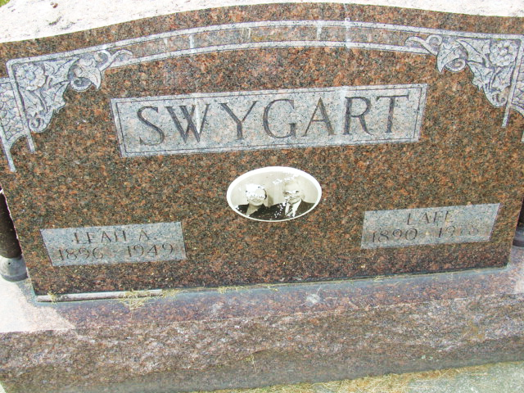
Photo by Alicia Kneuss

Leah A Swygart
in the Indiana, U.S., Death Certificates, 1899-2017

Name Leah A Swygart
[Leah A Dibble]
Gender Female
Race White
Marital Status Married
Age 52
Birth Date 18 Apr 1896
Birth Place Indiana
Death Date 20 Feb 1949
Death Place Decatur, Adams, Indiana, USA
Death Registration Date 1949
Father Burt Dibble
Mother Catherine Hertle
Informant Mrs. Norma J. Uhrick
Burial February 23, 1949; Decatur Cemetery; Decatur, Indiana

