Lafayette “Lafe” Swygart
April 14, 1890 – March 7, 1978

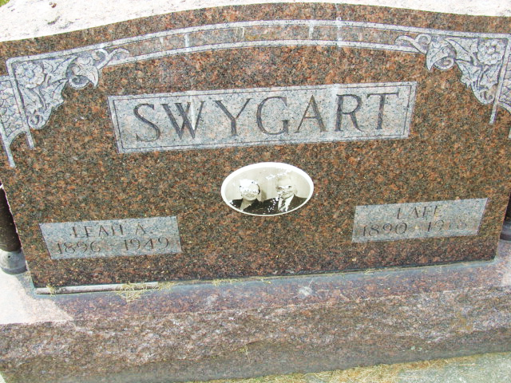
Photo by Alicia Kneuss

Lafayette Swygart
in the Indiana, U.S., Death Certificates, 1899-2017

Name Lafayette Swygart
Gender Male
Race White
Marital Status Widowed
Age 87
Birth Date 14 Apr 1890
Birth Place Ohio
Death Date 7 Mar 1978
Death Place Decatur, Adams, Indiana, USA
Death Registration Date 1978
Father Frank Swygart
Mother Belle Wilson
Informant Jack Swygart; Monroeville, Indiana
Burial March 10, 1978; Decatur Cemetery; Decatur, Indiana

