Jack Swygart
December 14, 1931 – November 24, 2005

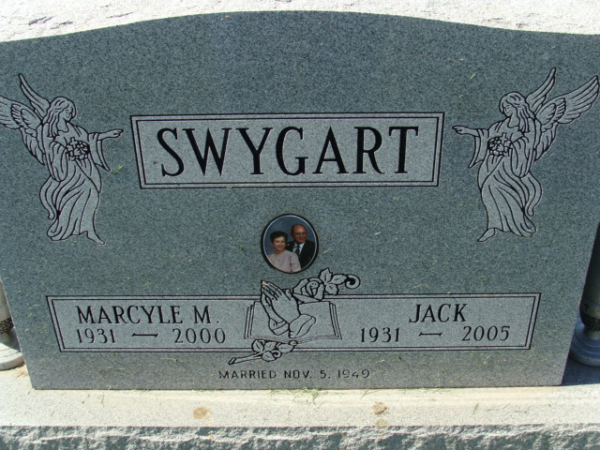
Photo by Alicia Kneuss

JACK SWYGART, 73, of Monroeville, died Thursday, Nov. 24, 2005, at Hospice Home, Fort Wayne. Born Dec. 14, 1931, in Decatur, he was the son of Leah A. (Dibble) and Lafe Swygart. He married his first wife, Marcyle M. (Geimer) on Nov. 5, 1948; she died on Jan. 18, 2000, and his second wife, Leila J. (Bassett) Reas on July 7, 2000.
He retired from Conrail Rail Road after 28 yrs. of service, in 1996. He was a member of St. John the Baptist Catholic Church, New Haven, and was former Town Marshall of Monroeville, from 1964 to 1968.
Surviving are wife, L. "Jean" Reas of Monroeville; six sons, William I. Swygart and John E. Swygart, both of Hoagland, Kenneth W. Swygart of Plymouth, Daniel L. Swygart of South Bend, Stephen J. Swygart of Monroeville and Michael L. Swygart of Wakarusa; two stepdaughters, Mrs. David (Linda) Anderson and Nila Baker, both of Monroeville; four brothers, Richard Swygart of Chester, S.C., Paul Swygart of Wells, Mass., Gerald Swygart of Leo and Lafe Swygart Jr. of Augusta, Ga.; 19 grandchildren; five step grandchildren; two great- grandchildren; and two step-great-grandchildren.
He was also preceded in death by his parents; three sisters; three brothers; and one grandson, Bryan.
Mass of Christian Burial is 10 a.m. Tuesday at St. Mary of the Assumption Catholic Church. Fr. Paul McCarthy officiating. Prayer service is 9:20 a.m. Tuesday at Haggard & Sefton Funeral Home, Decatur. Visitation is from 5 to 8 p.m. Monday at the funeral home. Burial in Decatur Cemetery, Decatur. Memorials to Hospice Home.

Journal Gazette, The (Allen County, Indiana)
Sunday, November 27, 2005

