Deloris Jean (Clark) Swygart
December 25, 1927 – November 8, 1947

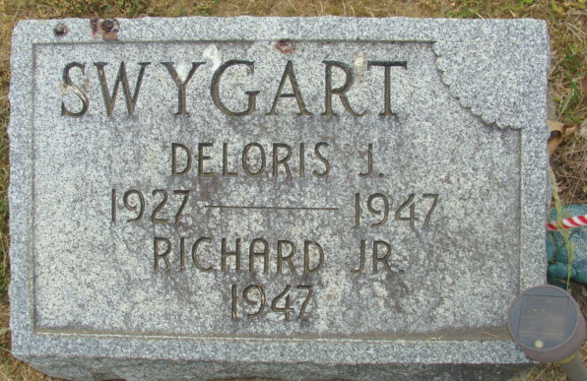
Photos by Alicia Kneuss

Deloris Jean Swaggart
in the Indiana, U.S., Death Certificates, 1899-2017

Name Deloris Jean Swygart
[Deloris Jean Clark]
Gender Female
Race White
Marital Status Married
Age 19
Birth Date 25 Dec 1927
Birth Place Ohio
Death Date 8 Nov 1947; post-partem hemorrhage
Death Place Decatur, Adams, Indiana, USA
Death Registration Date 1947
Father Henry Clark
Mother Treva Garwood
Spouse Richard Dale Swygart; age 24
Informant Richard Swygart; Decatur, Indiana
Burial November 11, 1947; Decatur Cemetery; Decatur, Indiana

