Cuffy Duane Swygart
July 22, 1957 – June 15, 1974

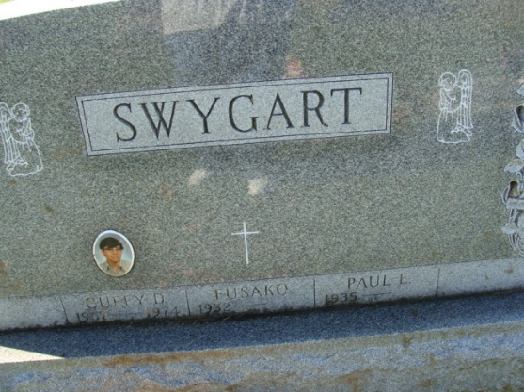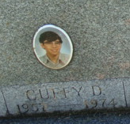
Photos by Alicia Kneuss

Cuffy D. Swygart, age16, dies in car-train-mishap

The fifth person to die on Adams county roadways thus far into 1974 was Cuffy D. Swygart, 16, route 1,Monroe,who was killed in a car-train collision at 3:55 p.m. Saturday on the Salem Road about 2 ½ miles south of Decatur.
The engineer of Norfolk and Western train, Robert G. Ross, 46, Frankfort, Ind., said the Swygart youth tried to miss the train, but couldn't and the car was smashed into on the driver's side, probably killing the boy instantly or very soon after the impact. The boy's injuries included a crushed chest, crushed skull, broken neck, leg fractures, and internal injuries.
Property damage was $1000 to the engine, which was pulling three cars and a caboose, while the Swygart car was demolished.
Three other of the county's 1974 fatalities have occurred in the same general area southeast of Decatur-two men died in a single-car crash in Pleasant Mills on US 33 and another man was killed on 33 south of Pleasant Mills.
Investigating and assisting each other at the accident were deputy sheriff Dick Maley, Decatur policeman Robert Noack, the Monroe Rescue Squad, and reserve deputy sheriffs, Jim Hueston, Leo White and Steve Riley.
Funeral services for Cuffy D. Swygart, age 16 of route 1, Monroe, killed instantly Saturday afternoon while driving his car across the Norfolk-Western Railroad crossing on road 200 North near the Decatur Drive-In, will be held at 2 p.m. Tuesday in the Monroe United Brethren Church, with Rev. M.C. Macklin officiating. Burial will be in Decatur cemetery.
The Swygart lad suffered severe skull, neck and chest injuries, and multiple fractures of his arms and legs. He was an employee of Hammond's IGA store and a member of the Adams Central high school track team, where he would have started his junior year this fall.
He was born in Pennsylvania on July 22, 1957, the son of Paul and Fusako Kubo-Swygart and attended the Monroe United Brethren Church.
Surviving are his mother, Mrs. Fusako Swygart of route 1, Monroe; his father, Paul Swygart of Maine; one brother, Paul Edward, at home; one sister, Francela Swygart, at home; a maternal grandmother, Mrs. Hatoya Kubo of Nagoya, Japan; the paternal grandfather and step-grandmother, Mr. and Mrs. Lafe Swygart, residing in the Decatur Community Care Center.
Friends may call at the Gillig-Doan & Sefton funeral home until Tuesday noon when the body will be removed to the church to lie in state prior to the 2 p.m. services.

Decatur Daily Democrat, Adams County, Indiana
Monday, June 17, 1974

