Mayme E. (Cloud) Swoveland
September 19, 1887 – January 28, 1965

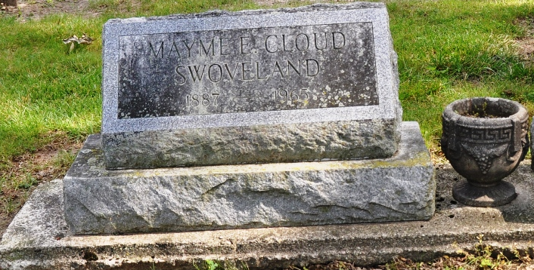
Photos by Deb curry

Widow of H. O. Swoveland Dies on Thursday
Broken Hip Fatal to 76-Year-Old Woman; Rites Sunday

Mrs. Mamie Cloud Swoveland, 76, Monroe R. R. 1, died at 1:30 p.m. Thursday at the Adams County Memorial Hospital where she had been a patient two weeks. She suffered a broken hip recently and complications developed. She was the widow of H. Swoveland who died Nov. 23, 1961.
Mrs. Swoveland was born Sept. 19, 1888 in Decatur, a daughter of Clinton C. and Jane Steele Cloud. She was married to Mr. Swoveland March 19, 1936.
Surviving are three daughters, Mrs. Marvin (Norma) Haines, Monroe R. R. 1, Mrs. Orval (Vera) Jones, Berne, R. R. 2 and Mrs. Irenios (Mary) Mattax, Mendon, Michigan; 8 grandchildren and 20 great-grandchildren. Five brothers and three sisters preceded in death.
The body is at the Zwick Funeral Home in Decatur where friends may call after 2 p.m. Saturday. Services will be held there at 1:30 p.m. Sunday, Rev. Frank Voss and Rev. Hilas Custer, the latter of Willshire, Ohio, officiating. Burial will be in the Decatur Cemetery.
Mrs. Swoveland was a member of the Willshire UB Church. She was employed as secretary to the late French Quinn, noted historian, for many years and also was employed in the county clerk's office in Decatur.

The Berne Witness, Adams County, Indiana
Friday, January 29, 1965

