Norman Sweet
August 22, 1886 – October 23, 1954

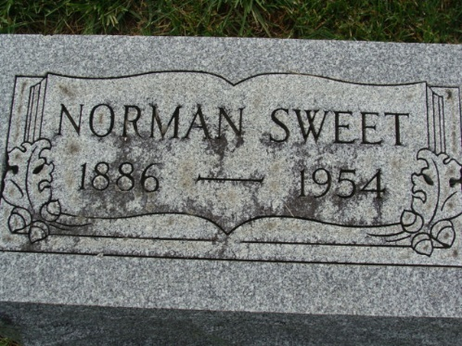
Photos by Alicia Kneuss

Dr Norman Sweet, 68, a practicing psychoanalyst here, died at 11:30 am yesterday in St Joseph's Hospital, where he had been a patient one week. He was being treated for pneumonia.
Dr Sweet, a radio announcer here in the early days of radio was a native of Cedar Rapids, Ia, and had resided in Fort Wayne 25 years. His home was at 2214 Bowser Ave. In 1940, Dr Sweet was Republican nominee for Congress from the Fourth District.
Surviving are the widow, Florence; a son, Norman Sweet Jr, Louisville, Ky; a brother, Edward D Sweet, New Orleans, La, and two grandchildren.
The body was taken to the DO McComb & Sons Funeral Home, where friends may call after noon today. Services will be held at 10 am Monday in the funeral home, the Rev E. E. Petznik officiating. Burial will be in Maplewood Cemetery at Decatur.

Fort Wayne Journal Gazette, Allen County, Indiana
October 24, 1954
**

Indiana, U.S., Death Certificates, 1899-2017

Name Norman Sweet
Gender Male
Race White
Marital Status Married
Age 68
Birth Date 22 Aug 1886
Birth Place Iowa
Death Date 23 Oct 1954
Death Place Fort Wayne, Allen, Indiana, USA
Father Thomas Sweet
Mother Edith Merrill
Informant Mrs. Florence Sweet; Fort Wayne, Indiana
Burial October 25, 1954; Maplewood Cemetery; Decatur, Indiana

