Edna Catherine Swearingen
October 3, 1908 – September 30, 1922

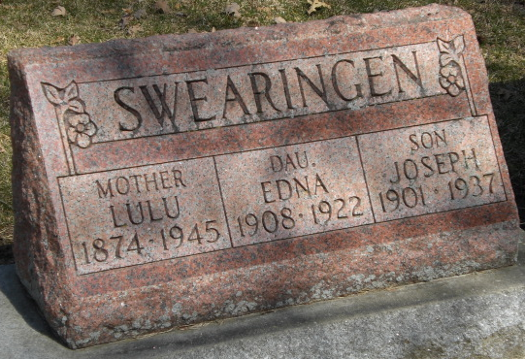
Photos by Corgilover

Edna Catherine Swearingen, better known to all her little friends as “Sunnie,” was born October 3, 1908, and passed into eternal life September 30th, just three days before her fourteenth birthday, which she is spending with the angels.
God deemed her too frail to meet the storms of an earthly life, so took her to live with Jesus, who said: “Suffer the little children to come unto Me, for such is the Kingdom of Heaven." Those who love her grieve her departure, but are consoled in the thought that she is much happier in the land where she may have all the joy of eternal life unalloyed by the clouds and sorrows that surround those left behind.
“Sunnie” had a magnetic disposition that drew both old and young to her. Her happy smile was for everyone. Every energy she had she put into the best in life, and received in turn, all life enjoyments. Just as she put her little life, heart, and soul, into playing tennis, she did in her schoolwork and all. We grieve, but She will never grow old, nor weary, nor sad. She's a beautiful lily whose leaves will unfold in a climb that is purer and brighter than earth, in a Kingdom of Light, but she'll never grow old, nor weary, nor sad. Our love will last as pure and whole as when she loved us here. It can never die.
Her enthusiasm made her a joy to her teachers and her disposition made her loved dearly by her schoolmates. Her one little friend, Martha, who is away now, will find it so hard when she comes back and finds her gone. Her grandfather, to whom she has been a constant companion during his illness, will more than miss her.

Decatur Daily Democrat, Adams County, Indiana
Wednesday, October 11, 1922

**
Popular Young Girl Succumbs Miss Edna Swearingen
Died at 2:25 O'clock This Afternoon

Miss Edna Catherine Swearingen, age 13 years, died at her home on the corner of Marshall and Third streets at 2:25 o'clock this afternoon, following a short illness with Purpura Haemorrhagica. The disease is a very peculiar one affecting the blood vessels. The blood vessels do not retain the blood and the blood escapes into the tissues causing large blood blisters. This disease did not develop until within the last few days although the girl has been ill for the last two weeks. A consultation was held by physicians this morning in an effort to save the girl's life.
Miss Swearingen was a very popular girl and was a student at the local high school. She was born on October 13, 1908.
She is survived by her mother, Mrs. Lulu Swearingen; two sisters and two brothers. The sisters are Helen at home, and Anita, at present a student at Indiana University, at Bloomington, Indiana. The brothers are Milton, at home, and Joseph, of Des Moines, Iowa.
Funeral arrangements will not be made until word has been received from the brother and sister who are away from home.

Decatur Daily Democrat, Adams County, Indiana
September 30, 1922

