Jesse A. Swartz
March 7, 1876 – August 22, 1970

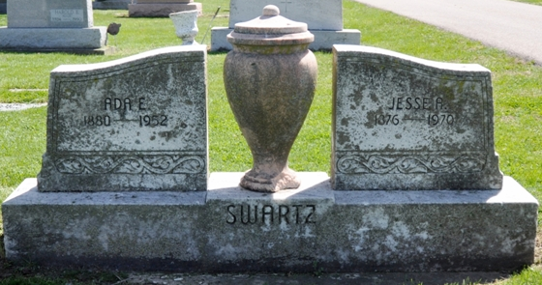
Photo by Deb Curry

Jesse Swartz, 94, dies early today

Jesse A. Swartz, 94, of 816 West Monroe Street, a 50-year resident of Decatur, and a retired mail carrier, died at 12:30 a.m. today at the Adams County Memorial Hospital, where he had been a patient for the past four weeks.
Born in Root Township March 7, 1876, he was a son of Lewis P. and Marty Swartz, and was married to Ada E. Archbold Oct. 5, 1899. His wife preceded him in death Aug. 7, 1952. Mrs. Swartz was a member of the Church of the Nazarene.
Surviving is one daughter, Mrs. Russell (Lola) Baumgartner of Decatur; one sister, Mrs. Nina Light of Decatur three grandchildren and nine great-grandchildren. One son, Harold; one brother and two sisters are deceased.
Funeral services will be conducted at 1:30 p.m. Monday at the Zwick Funeral Home, with Rev. Leonard Foster officiating. Burial will be in the Decatur Cemetery. Friends may call at the funeral home after 7 p.m. today until time of the services.

Decatur Daily Democrat, Adams County, Indiana
Saturday, Aug. 22, 1970
**

Indiana, U.S., Death Certificates, 1899-2017

Name Jesse A Swartz
Gender Male; Race White; Marital Status Widowed; Age 94
Birth Date 7 Mar 1876; Birth Place Indiana
Death Date 22 Aug 1970; Death Place Decatur, Adams, Indiana, USA
Father Lewis P Swartz
Mother Mary [Steele]
Informant Mrs. Russell Baumgartner; daughter; Decatur, Indiana
Burial August 24, 1970; Decatur Cemetery; Decatur, Indiana

