C. Harold Swartz
October 2, 1901 – July 17, 1948

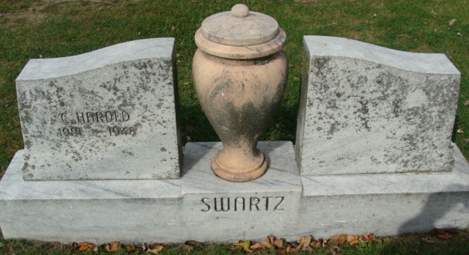
Photo by Alicia Kneuss

C Harold Swartz
in the Indiana, U.S., Death Certificates, 1899-2017

Name C Harold Swartz
Gender Male
Race White
Marital Status Married
Age 46
Birth Date 2 Oct 1901
Birth Place Adams County, Indiana
Death Date 17 Jul 1948
Death Place Decatur, Adams, Indiana, USA
Death Registration Date 1948
Father Jesse Swartz
Mother Ada Archbold
Spouse Myrtle; age 46
Informant Jesse Swartz; Decatur, Indiana
Burial July 20, 1948; Decatur Cemetery; Decatur, Indiana

