Ada E. (Archbold) Swartz
April 19, 1880 – August 7, 1952

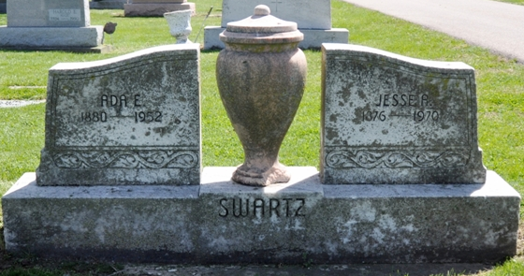
Photo by Deb Curry

Indiana, U.S., Death Certificates, 1899-2017
Name Ada E Swartz
[Ada E Archbald]
Gender Female
Race White
Age 72
Marital Status Married
Birth Date 19 Apr 1880
Birth Place Indiana
Death Date 7 Aug 1952
Death Place Decatur, Adams, Indiana, USA
Death Registration Date 1952
Father James M Archbald
Mother Mary Catharine Summers
Informant Jesse Swartz
Burial Decatur Cemetery 8-11-1952

