Janet Joan (Bragg) Swales
May 12, 1940 – August 14, 2023

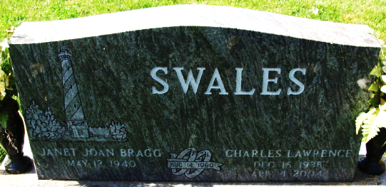
Photo by Alicia Kneuss

It is with great sadness that the family of Janet J. Swales, 83, of Decatur, IN announce her passing on Monday, August 14, 2023. She was born to Kenneth and Winifred (Hensel) Bragg on May 12, 1940, in Huntington, IN and lived there until her marriage to Charles L. Swales on August 14, 1960. After some time in CA, they moved to Decatur, where she settled after a few years at DeVoss, Scott, Johnson & Baker as a legal secretary until her retirement.
Janet will be lovingly remembered by her children, Ken (Patty) Swales of Decatur, IN and Jodi (J. Doug) Brewer of Chicago, IL; grandchildren, Jamie and Jon Swales and Maddie, Jackson and Ethan Brewer; her aunt, Gloria Burkhart of Smithfield, NC and sister-in-law, Carol Bragg of Morristown, TN.
She was preceded by her husband, (Charles) Larry Swales, April 4, 2004 and her brother, Kent “Butch” Bragg, July 27, 2016.
Janet was a caring wife, mother, grandmother, sister, and friend. She loved Christmas and making cookies to give to family and friends, reading and relaxing at the lake, traveling and in her younger days bowling and euchre parties. Later she attended New Hope Church and occasional day trips with friends. She will always be loved, never forgotten, and forever missed.
Visitation will be from 4:00 – 7:00 p.m. Thursday, August 17, 2023, at Haggard-Hirschy & Zelt Funeral Home. A Funeral Service will be held at 10:30 a.m. Friday, August 18, 2023, at Haggard-Hirschy & Zelt Funeral Home. Rev. Rick Harris will be officiating and burial will follow in Decatur Cemetery.
In lieu of flowers, please donate to the Adams County Democratic Party or New Hope Church.

Haggard & Sefton Funeral Home, Adams County, Indiana
August 14, 2023

