Charles Lawrence Swales
December 16, 1938 – April 4, 2004

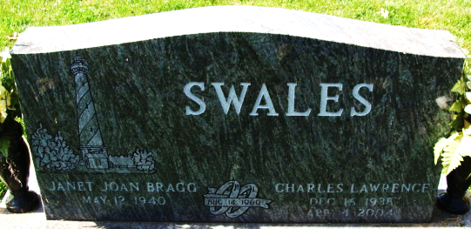
Photo by Alicia Kneuss

Charles L. Swales, 65, of Decatur, died Sunday, April 4, 2004.
Arrangements by Haggard & Sefton Funeral Home, Decatur.

Journal Gazette, Allen County, Indiana
Monday, April 5, 2004
**

Adams County Public Library (Decatur, IN) online obit abstracts

Decatur Daily Democrat; 06 APR 2004, p. 2A
Swales, Charles L. Obituaries -- S -- 2000- Age: 65 Died: April 4, 2004 Born: December 16, 1938 - Huntington, Indiana Son of: William & Mary Hartman Swales Married: Janet Bragg - August 14, 1960; she survives Children: Ken Swales & Mrs. James D. (Jodi) Brewer He retired in 2000 from North Ada...
**

Indiana, U.S., Death Certificates, 1899-2017

Name Charles L Swales
Gender Male
Race White
Marital Status Married
Age 65
Birth Date 16 Dec 1938
Birth Place Huntington, Indiana
Death Date 4 Apr 2004
Death Place Decatur, Adams, Indiana, USA
Father William Swales
Mother Mary Hartman
Spouse Janet Bragg
Informant Mrs. Janet (Bragg) Swales; wife; Decatur, Indiana
Burial April 8, 2004; Decatur Cemetery; Decatur, Indiana

