Thelma R. (Kern) Swager
January 25, 1907 – March 17, 1974

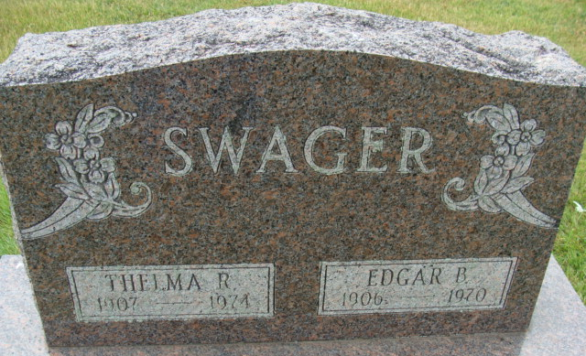
Photos by Alicia Kneuss

Thelma R. Swager Dies Unexpectedly
Mrs. Thelma R. Swager, 67, of 413 McBarnes St., widow of Edgar B. Swager, died in her sleep Sunday morning. She had not been ill and death was unexpected. Mrs. Swager was a member of the St. Mark’s United Methodist Church and the Mary Circle of the church.
Born in Decatur on January 25, 1907, she was the daughter of George and Blanch McBarnes-Kern, and was married on April 16, 1927, to Edgar B. Swager, who died Feb. 26, 1970.
Surviving are two children, Mrs. Max Mattax, of Fort Wayne, and Edgar G. Swager, of near Willshire, O., and seven grandchildren.
Funeral services will be held at 2 p.m. Wednesday at the Winteregg-Linn and Haggard Funeral Home, with Rev. William Harsin and Rev. Fuhrman Miller officiating. Burial will be in the Decatur Cemetery. Friends may call at the funeral home after 2 p.m. Tuesday.

Decatur Daily Democrat, Adams County, Indiana
Monday, March 18, 1974

