Edgar G. Swager
March 31, 1933 – August 26, 1978

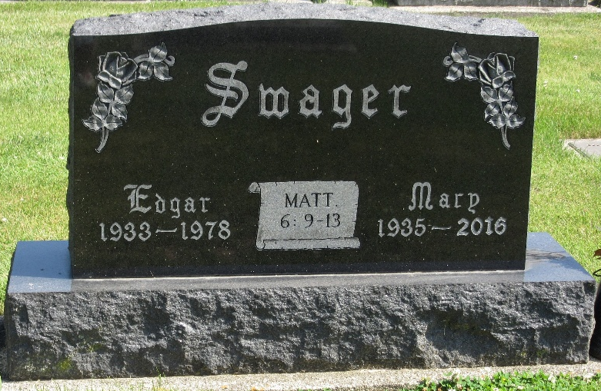
Photos by PLS

Edgar G Swager
in the Indiana, U.S., Death Certificates, 1899-2017

Name Edgar G Swager
Gender Male
Race White
Marital Status Married
Age 45
Birth Date 31 Mar 1933
Birth Place Indiana
Death Date 26 Aug 1978
Death Place Indianapolis, Marion, Indiana, USA
Death Registration Date 1978
Father Edgar Swager
Mother Thelma Kern
Spouse Mary
Informant Mary Swager; Willshire, Ohio
Burial August 30, 1978; Decatur Cemetery; Decatur, Indiana

