Edgar B. Swager
May 7, 1906 – February 26, 1970

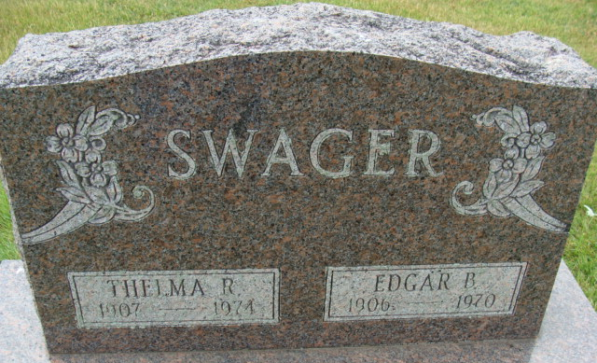
Photos by Alicia Kneuss

Edgar B. Swager Dies at Hospital
Edgar B. Swager, 63, of 413 McBarnes Street, died at 1:36 p.m. Thursday at the Adams County Memorial Hospital. He had been in failing health for several months but death was unexpected.
Born in Fort Wayne May 7, 1906, he was a son of Peter W. and Celia Sorg-Swager, and was married to Thelma R. Kern April 16, 1927. Mr. Swager, retired employee of the Decatur Casting Co., was a member of St. Mary's Catholic Church.
Surviving are his wife; one daughter, Mrs. Max (Roberta) Mattax of Fort Wayne; one son, Edgar G. Swager of near Willshire, O.; two sisters, Mrs. Henry (Marcella) Strauss of Fort Wayne and Mrs. Beatrice Forrester of Granger; an aunt, Mrs. Loretta Quinn of Granger and seven grandchildren.
Funeral rites will be held at 10 a.m. Monday at St. Mary's Catholic Church, with the Rt. Rev. Msgr. Simeon Schmitt officiating. Burial will be at Decatur Cemetery. Friends may call at the Winteregg-Linn Funeral Home after 7 p.m. Saturday until time of the services. The rosary will be recited at 8 p.m. Sunday.
Preferred memorials are to the Heart Fund.

Decatur Daily Democrat, Adams County, Indiana
Friday, February 27, 1970

