Mary Sutton
March 22, 1904 – May 14, 1906

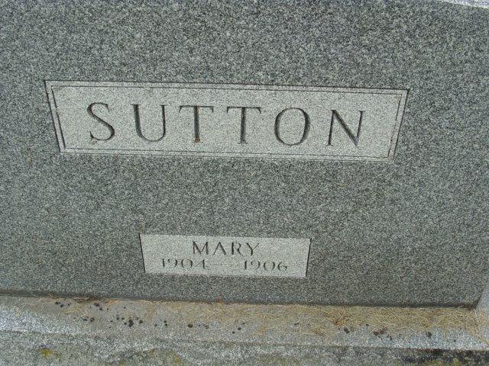
Photo by Alicia Kneuss

Mary Sutton
in the Indiana, U.S., Death Certificates, 1899-2017

Name Mary Sutton
Gender Female
Race White
Marital Status Single
Age 2 years, 1 month, 22 days
Birth Date 22 Mar 1904
Birth Place Adams County, Indiana
Death Date 14 May 1906
Death Place Decatur, Adams, Indiana, USA
Death Registration Date 1906
Father Jesse C Sutton
Mother Isabell G White
Informant Jesse C. Sutton; Decatur, Indiana
Burial May 15, 1906; Decatur Cemetery

