Jesse C. Sutton
April 29, 1875 – May 27, 1937

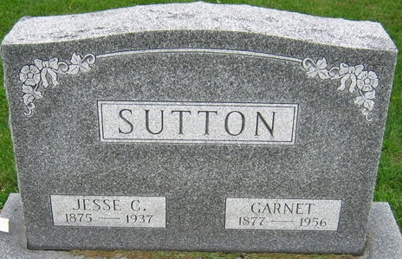
Photo by S Riley

Jesse C Sutton
in the Indiana, U.S., Death Certificates, 1899-2017

Name Jesse C Sutton
Gender Male
Race White
Marital Status Married
Age 62
Birth Date 29 Apr 1875
Birth Place Illinois
Death Date 27 May 1937
Death Place Wayne, Indiana, USA
Death Registration Date 1937
Father Winfield S Sutton
Mother Louise Murry
Spouse Isabella G
Informant Richmond State Hospital records
Burial May 29, 1937; Decatur, Indiana

