Garnet I. (White) Sutton
May 9, 1877 – October 23, 1956

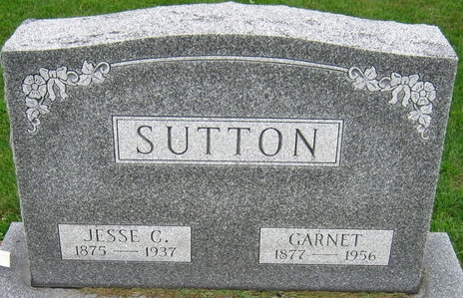
Photo by S Riley

WIDOW OF FORMER JUDGE SUTTON DIES
FUNERAL FOR PROMINENT DECATUR WOMAN, 79, ON THURSDAY
Mrs. Garnet Sutton, 79, widow of Jesse C. Sutton, former judge of the Adams Circuit Court, died at 2 p.m. Tuesday at the Adams County Memorial Hospital after a serious illness of three weeks. She was a resident of Decatur and had been hospitalized 10 days.
Mrs. Sutton served on the Decatur Library Board for four years and was a member of the Presbyterian Church, Shakespeare Club and Research Club. She had resided for the past 20 years with a son, Jesse C. Sutton.
Also surviving are four other sons, Murray R. Sutton, Columbus, Ohio; W. Alex Sutton, Indianapolis; Harry W. Sutton, Newton Center, Mass., and Richard L. Sutton, Coatesville; 12 grandchildren and a great grandchild.
The body is at the Zwick Funeral Home in Decatur where friends may call. Services will be conducted at 2 p.m. Thursday in the Presbyterian Church, Rev. Ray J. Walther officiating. Burial will be in the Decatur Cemetery.
Adams County Historical Museum, Adams County, Indiana
March 1955 – April 1958 Scrapbook
Handwritten date: Wednesday, October 24, 1956
**

Mrs. Garnet Sutton Is Taken By Death
Prominent Decatur Lady Dies Tuesday
Mrs. Garnet Sutton, 79, widow of Jesse C. Sutton, former judge of the Adams Circuit Court, died at 1:50 o’clock Tuesday afternoon at the Adams County Memorial Hospital. She had been seriously ill for three weeks and hospitalized for 10 days.
She was born near Ossian May 9, 1877, a daughter of Alexander and Mary Alice Rupright-White. Judge Sutton died May 27, 1937. She had made her home in this city with a son, Jesse C. Sutton, for the past 20 years.
Mrs. Sutton was a member of the First Presbyterian Church and the Shakespeare and Research Clubs. She also served for four years as a member of the board of the Decatur Public Library.
Surviving in addition to the son with whom she made her home are four other sons, W. Alex Sutton of Indianapolis, Murray R. Sutton of Columbus, 0., Harry W. Sutton of Newton Center, Mass., and Richard Y. Sutton of Coatesville; 12 grandchildren and one great-grandchild. One daughter, Mary, is deceased.
Funeral services will be conducted at 2 p.m. Thursday at the First Presbyterian Church, the Rev. Ray J. Walther officiating. Burial will be in the Decatur Cemetery. The body was removed to the Zwick Funeral Home, where friends may call until time of the services.
Decatur Daily Democrat, Adams County, Indiana
Wednesday, October 24, 1956
**
SUTTON FUNERAL IS HELD THIS AFTERNOON
Funeral services were held this afternoon at the First Presbyterian Church for Mrs. Garnet Sutton, prominent Decatur lady, who died Tuesday afternoon after a three week's illness. The Rev. Ray J. Walther officiated, and burial was in the Decatur Cemetery. Pallbearers for Mrs. Sutton, whose husband the late Jesse C. Sutton, was a former judge of the Adams Circuit, were C. H. Muselman, G. Remy Bierly, Lewis L. Smith, Judge Myles Parrish, Severin Schurger and Hubert McCleanahan.
Decatur Daily Democrat, Adams County, Indiana
Friday, October 25, 1956
**
Isabella Garnett White from tree Sherry Harris Family Tree
Birth 9 May 1877 Wells, Indiana, USA
Marriage 6 Oct 1898 Wells, Indiana, USA
Residence 1 Apr 1940 Decatur, Adams, Indiana, USA
Death 23 Oct 1956 Wells, Indiana, USA
Father Alexander White (1851-1921)
Mother Mary Alice Rupright (1853-1938)
Spouse Jesse Cary Sutton (1875-1937)

