Willard Buchanan Suttles
January 1, 1857 – May 16, 1937

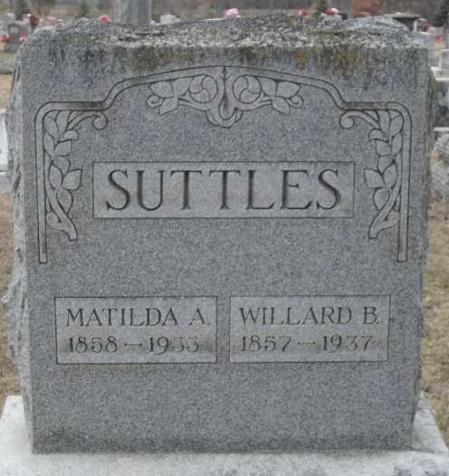
Photo by Stephen & Andrea Brangan

Twenty Years Ago Today - W. B. Suttles, 80, of Pa., formerly of Decatur, died today.

Decatur Daily Democrat, Adams County, Indiana
Friday, May 17, 1957
**

Indiana, U.S., Death Certificates, 1899-2017

Name Willard Buchanan Suttles
Gender Male
Race White
Marital Status Widowed
Age 80
Birth Date 1 Jan 1857
Birth Place Union Township, Indiana
Death Date 16 May 1937
Death Place Decatur, Adams, Indiana, USA
Death Registration Date 1937
Father William H Suttles
Mother Elizabeth J Humes
Spouse Mathilda A Baker
Informant Arthur Suttles; Decatur, Indiana
Burial May 19, 1937; Decatur Cemetery

