Matilda Ann (Baker) Suttles
March 7, 1858 – May 29, 1933

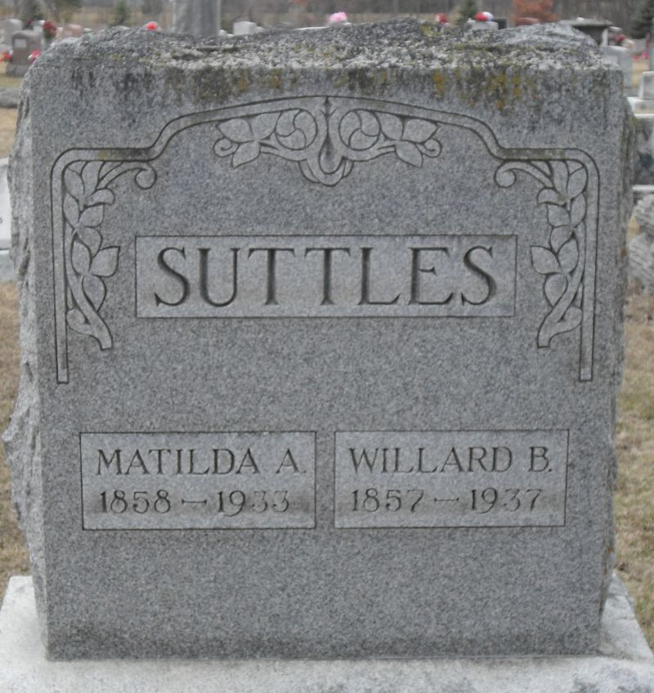
Photo by Stephen & Andrea Brangan

Matilda Ann Baker from tree Moser Family Tree

Birth 7 Mar 1858 Indiana, USA
Marriage 31 Dec 1876 Indiana, USA
Residence 1930 Albion, Erie, Pennsylvania, USA
Death 29 May 1933 Decatur, Adams, Indiana, USA
Father Jacob Baker (1819-1904)
Mother Hannah CONKLE (1827-1863)
Spouse Willard Buchanan Suttles (1857-1937)

