John E. Suttles
1881 – August 20, 1884

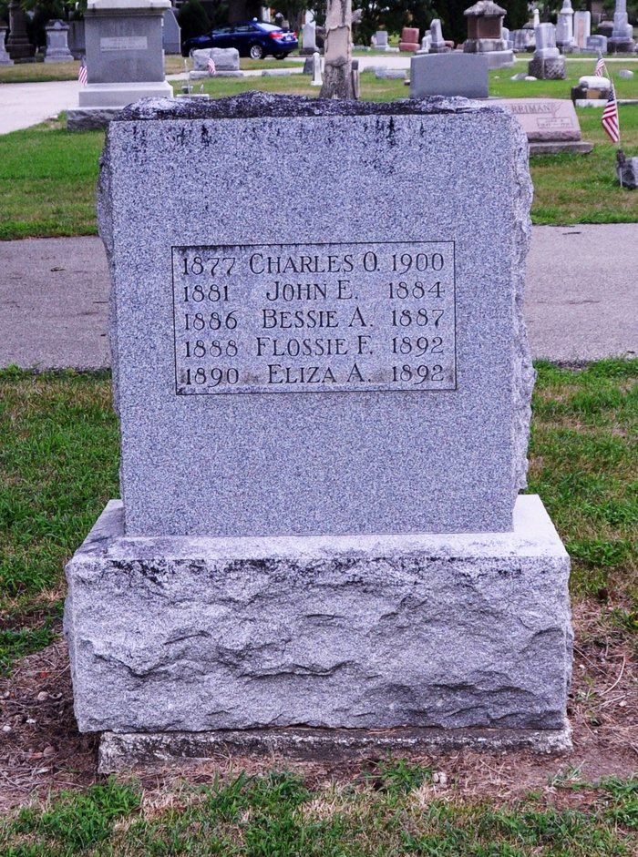
Photo by Deb Curry

At Decatur on the 20th, a child of W. B. Suttle’s, three years old caught fire in its clothing and was burnt to death.

Porter County Vidette, Valparaiso, Porter County, Indiana
August 28, 1884, p.7, col. 5

