Hattie N. (Niblick) Suttles
January 18, 1881 – May 29, 1966

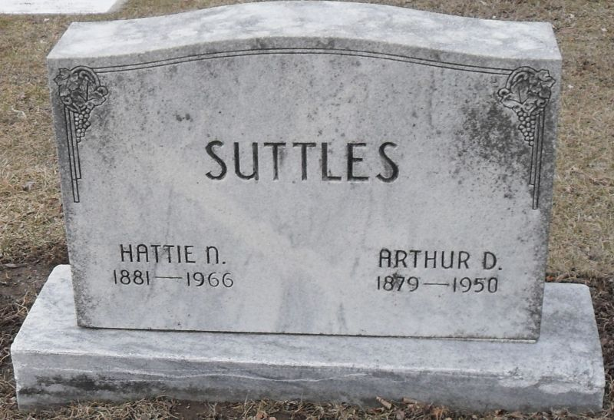
Photo by Stephen & Andrea Brangan

Hattie N Suttles
in the Indiana, U.S., Death Certificates, 1899-2017

Name Hattie N Suttles
[Hattie N Niblick]
Gender Female
Race Caucasian (White)
Marital Status Widowed
Age 85
Birth Date 18 Jan 1881
Birth Place Indiana
Death Date 29 May 1966
Death Place Decatur, Adams, Indiana, USA
Death Registration Date 1966
Father John Niblick
Mother Mary Jane Studebaker
Informant Arthur D. Suttles; son; Decatur, Indiana
Burial June 1, 1966; Decatur Cemetery; Decatur, Indiana

