Flossie F. Suttles
1888 - 1892

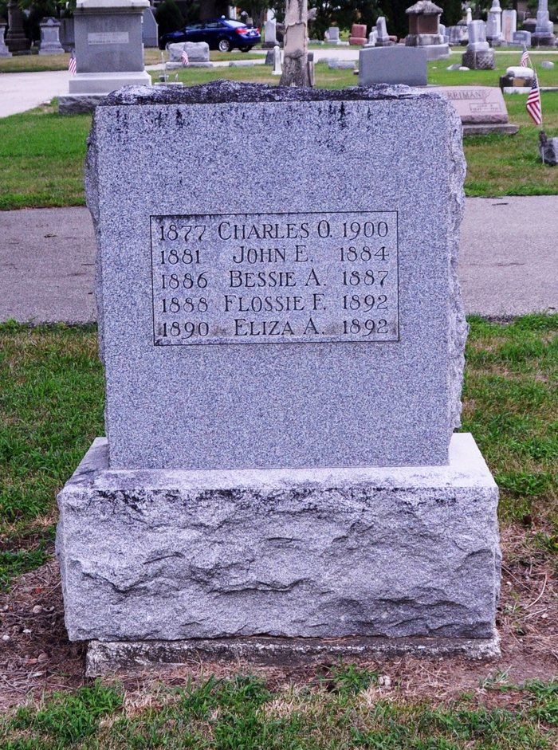
Photo by Deb Curry

No further information found at this time.

