Cleo Iverna Suttles
May 5, 1891 - March 7, 1906

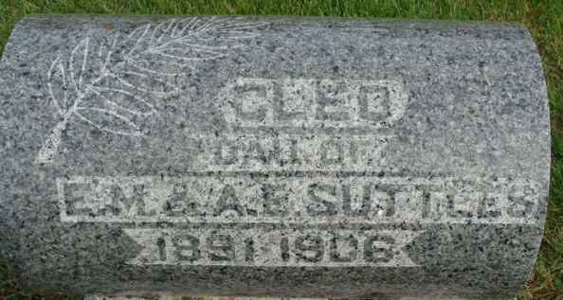
Photo by Deb Curry

Speaking of the death of Miss Cleo Suttles, whose funeral was held here Friday, the Huntington Herald said: Miss Cleo Iverna Suttles, daughter of Mr. and Mrs. Ernest Suttles, of 45 West Sabine Street, died Wednesday afternoon at 3 o'clock at her parents’ home. Miss Suttles had been in ill health since the week before Christmas. Appendicitis developed but after several slight attacks, she grew much better. A week ago last Tuesday she was taken to the hospital and the day following, submitted to an operation. The patient rallied from the operation and did nicely until symptoms of a rash were evident Tuesday and her removal from the hospital during the yet early stages of new affliction was considered imperative to the welfare of other patients and Miss Suttles was taken home Wednesday morning.
Dr. Charles L. Wright of the county board of health, made a statement to the Herald this morning as to the immediate cause of the young lady's death: "Death following an attack of uremic poisoning, due to a well-developed case of scarlet fever." In her impaired physical condition as a result of the operation, the patient was unable to survive the shock.
The deceased was born in this city shortly after the family moved here from Decatur, fifteen years ago. Her age was fourteen years, ten months and two days.
Besides the parents, the little brother, Walter, is left in the family to mourn this death. She was a member of the Baptist church and was an active worker in the B.Y.P.U. (?) society.
Decatur Democrat, Adams County, Indiana
(a weekly newspaper)
Thursday, March 15, 1906
**

Indiana, Death Certificates, 1899-2011
Name: Cleo Iverna Suttles
Gender: Female
Race: White
Age: 14
Marital status: Single
Birth Date: 5 May 1891
Birth Place: Huntington Ind
Death Date: 7 Mar 1906
Death Place: Huntington, Huntington, Indiana, USA
Father: Earnest Suttles
Mother: Amanda Hower
Informant: Earnest Suttles
Burial: March 9, 1906; Decatur Cem.

