Charles O Suttles
1887 - 1900

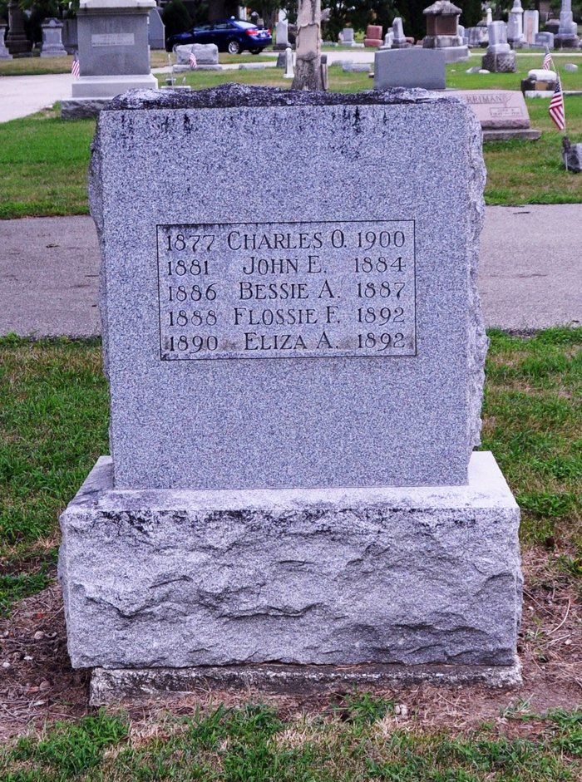
Photo by Deb Curry

No further information found at this time.

