Bessie A. Suttles
1886 - 1887

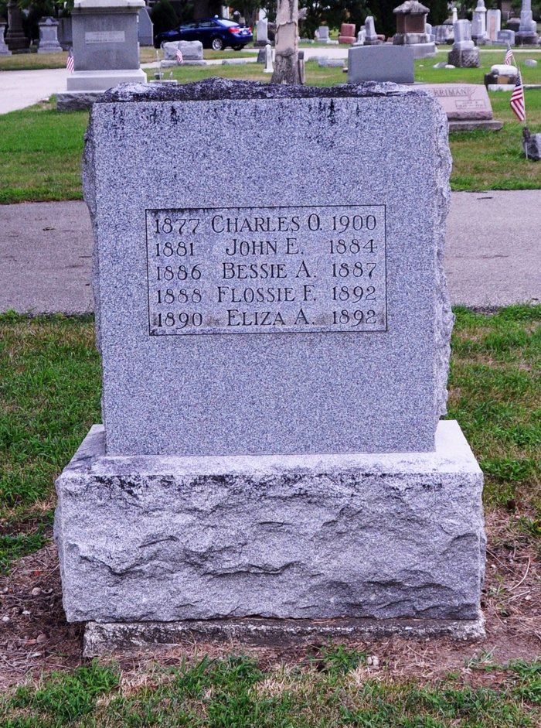
Photo by Deb Curry

No further information found at this time.

