Arthur D. Suttles
May 5, 1891 - March 7, 1906

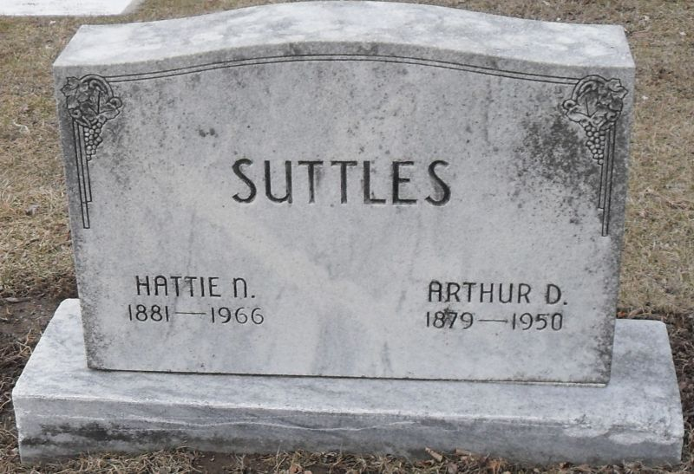
Photo by Stephen & Andrea Brangan

Arthur D. Suttles Dies In Decatur

Decatur, Ind., March 17 – Arthur D. Suttles, 70, prominent Decatur businessman and civic leader, died unexpectedly Thursday about 10 a.m. at his home following a heart attack. He had gone to the post office and upon his return home he became ill.
Mr. Suttles founded the Suttles Company, an insurance and real estate firm here, 27 years ago. He was active in church, civic and fraternal organizations. He was a charter member and past president of the Rotary Club, a member of the First Methodist Church, the Masonic Lodge, the Mizpah Shrine, Fort Wayne, the BPO Elks and the Knights of Pythias.
Mr. Suttles was born August 16, 1879, in Berne. He was graduated from Decatur High School. After attending the Angola Teachers College he taught school here and later became principal of a grade school.
Surviving are the wife, Hattie; three daughters, Mrs. Richard Archbold, Coldwater, Mich.; Mrs. John Conkins, Columbus, O., and Mrs. Herbert Kallenberg, Anderson; one son, Arthur, Jr., Utica, N. Y.; six grandchildren, two brothers, Robert, Wesleyville, Pa., and Harold, Sharon, Pa., and two sisters, Mrs. Ruth McCummons, Wesleyville, and Mrs. Charles Sauer, Seoul, Korea.
Funeral services will be conducted at 2 p.m. Saturday in the First Methodist Church, Dr. Gerald H. Jones officiating. Burial will be in Decatur Cemetery. The body is at the Zwick Funeral Home where friends may call after 3:30 p.m. today.

Portland Commercial Review, Jay County, Indiana
March 17, 1950
**

Indiana, U.S., Death Certificates, 1899-2017

Name Arthur D Suttles
Gender Male
Race White
Marital Status Married
Age 70
Birth Date 16 Aug 1879
Birth Place Berne, Indiana
Death Date 16 Mar 1950
Death Place Decatur, Adams, Indiana, USA
Death Registration Date 1950
Father Williard Suttles
Mother Mathilda Baker
Informant Mrs. Harriet Suttles; Decatur, Indiana
Burial March 18, 1950; Decatur Cemetery; Decatur, Indiana

