Lessie L. Sutherland
August 12, 1883 – May 3, 1902

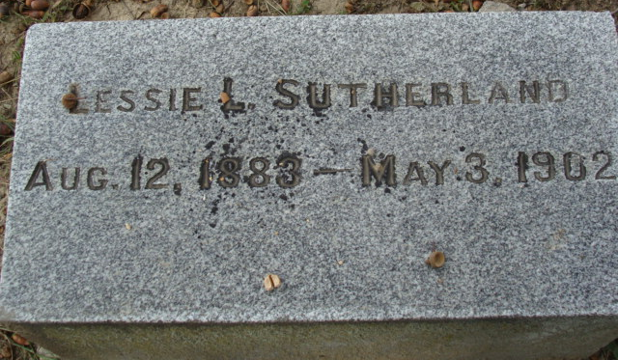
Photo by Alicia Kneuss

Miss Lessie Sutherland died Saturday afternoon at the home of her mother in the south part of town as a result of a long seige of tuberculosis. For several years she has been in failing health and it was feared that her lungs were affected. However, it was hoped that with good care she might be able to outgrow the terrible affliction, but several months ago symptoms developed of such a nature as to warn her friends that she could be with them but a short time. She kept up wonderfully and was only confined to her bed a few days. Her mother, who for years has given her every care possible, is heartbroken, and deserves the sympathy of all. Lessie was a bright and attractive young lady and had many admirers and true friends among her acquaintances. She was eighteen years of age. The funeral services were conducted Tuesday afternoon by Rev. Allen from the Presbyterian church.
Decatur Democrat; Adams County, Indiana
(a weekly newspaper)
Thursday, May 8, 1902
**
Indiana, U.S., Death Certificates, 1899-2011
Name: Lessie Sutherland
Gender: Female; Race: White
Age: 18; Marital status: Single
Birth Date: 12 Aug 1883; Birth Place: Ashland Co., O.
Death Date: 3 May 1902; Death Place: Adams Co., Indiana, USA
Father: Harry Sutherland
Mother: Carrie Inverse??
Informant: Mrs. Carrie Sutherland; Decatur, Indiana
Burial: No date; no place of burial stated

