William J. Susdorf
July 21, 1930 – December 6, 2002

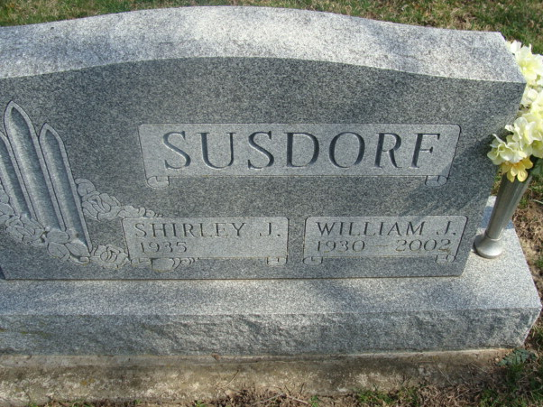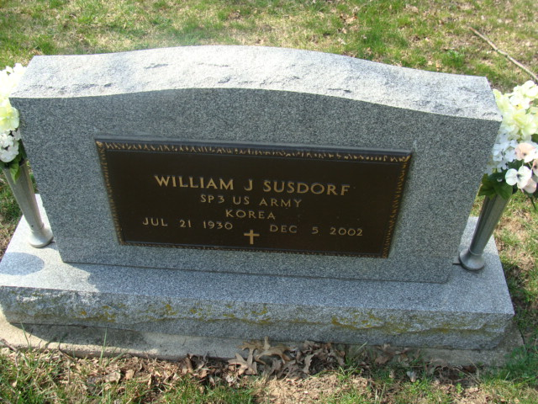
Photos by Alicia Kness

William J Susdorf
in the Indiana, U.S., Death Certificates, 1899-2017

Name William J Susdorf
Gender Male
Race White
Marital Status Married
Age 72
Birth Date 21 Jul 1930
Birth Place Chicago, Illinois
Death Date 5 Dec 2002
Death Place Decatur, Adams, Indiana, USA
Death Registration Date 2002
Father Archie Susdorf
Mother Florence Flaqq
Spouse Shirley Endsley
Informant Shirley Susdorf; wife; Decatur, Indiana
Burial December 8, 2002; Decatur Cemetery; Decatur, Indiana

