Shirley Jean (Endsley) Susdorf
October 29, 1935 -

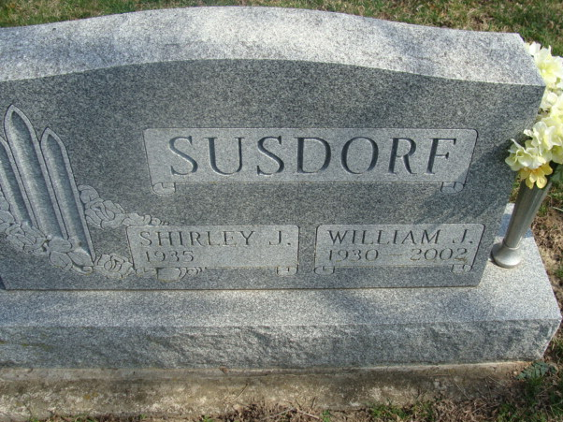
Photo by Alicia Kness

Shirley Jean Endsley
in the Indiana, U.S., Birth Certificates, 1907-1944

Name Shirley Jean Endsley
Gender Female
Birth Date 29 Oct 1935
Birth Place Ft Wayne, Allen, Indiana, USA
Father Guy Endsley; age 29
Mother Goldie Catherine Hostetler; age 28; 4th child, 3 living
Certificate Number 39764
Roll number 40474_357210
Volume Range 78 - 82

**
Indiana, U.S., Marriage Certificates, 1960-2012

Name Shirley Jean Endsley
Marriage Age 18
Birth Date 29 Oct 1935
Marriage Date 1 Nov 1953
Marriage Place Allen, Indiana, USA
Spouse William John Susdorf

