Tina Rose (Kang) Summers
September 29, 1931 – November 2, 2009

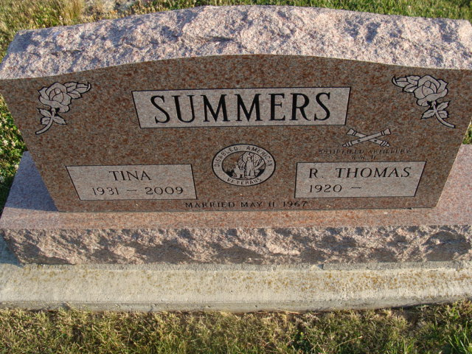
Photo by Alicia Kneuss

TINA ROSE SUMMERS, 78, of Fort Wayne, died Monday, Nov. 2, 2009, 10:42 p.m., at Lutheran Life Villages where she had been a patient since December of 2007. Born Sept. 29, 1931, in Pusan, Korea, she was a homemaker. She married Raymond Thomas Summers on May 11, 1967, in Seoul, Korea; he survives in Fort Wayne.
Also surviving are her brother-in-law, Ed Summers of Decatur; sister- in-law, Evelyn (Allen) Felt of Decatur; and many nephews and nieces.
Graveside service is noon Thursday at Decatur Cemetery. The Rev. Jim Johnson officiating. Private family visitation. Preferred memorials to the donor's choice. For complete obituary information and to sign the online guestbook, visit www.zwickjahn.com. Zwick & Jahn, the Exclusive Provider in Adams and Allen County for: "Veterans & Family Memorial Care"

News-Sentinel, The (Allen County, Indiana)
Wednesday, November 4, 2009
**

Indiana, U.S., Death Certificates, 1899-2017

Name Tina Rose Summers
[Tina Rose Kang]
Maiden Name Kang
Gender Female
Race Korean
Marital Status Married
Age 78
Birth Date 29 Sep 1931
Birth Place Pusan, Korea
Death Date 2 Nov 2009
Death Place Fort Wayne, Allen, Indiana, USA
Death Registration Date 2009
Father Che Kun Kang
Mother Kum Ok Yu
Spouse Raymond Thomas Summers
Informant Raymond Summers; husband; Fort Wayne, Indiana
Burial Decatur Cemetery; Decatur, Indiana

