Rose Eva (Hoffman) Summers
June 1, 1886 – January 12, 1974

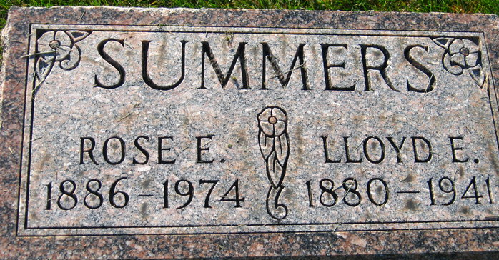
Photos by S Riley

Rose Summers, 87, Dies this Morning
Mrs. Rose Summers, 87, of route 2, Monroeville, widow of Lloyd E. Summers, died at 12:10 a.m. today at Parkview Memorial Hospital, Fort Wayne; where she had been hospitalized four weeks. She was a member of the St. John Lutheran Church, Flatrock.
Born in Howard Lake, Minn., on June 1, 1886, she was the daughter of John and Malinda Miller-Hoffman, and was married on August 17, 1912, to Lloyd E. Summers, who died in 1941.
Surviving are eight children, Mrs. Edward (Dorothy) Lunn of San Bernardino, California; James of Grafton, N.D.; Mrs. Allen (Evelyn) Felt of route 2, Monroeville, with who she made her home for the past 20 years; Walter H., Mrs. Orval (Martha) Morris and R. Thomas, all of Fort Wayne; Ms. Merrill (Mary) Johnson and Edward, both of Decatur; 21 grandchildren and nine great-grandchildren. One brother, Herman Hoffman, and three grandchildren preceded her in death.
Funeral services will be held Tuesday at 1:30 p.m. at the Zwick Funeral Home, with Rev. Donald E. Frank officiating. Burial will be in the Decatur Cemetery. Friends may call at the funeral home after 2 p.m. Sunday.
Preferred memorials are to the St. John Building Fund, Flatrock.

Decatur Daily Democrat, Adams County, Indiana
Saturday, January 12, 1974

