Raymond Thomas Summers
September 7, 1920 – February 27, 2016

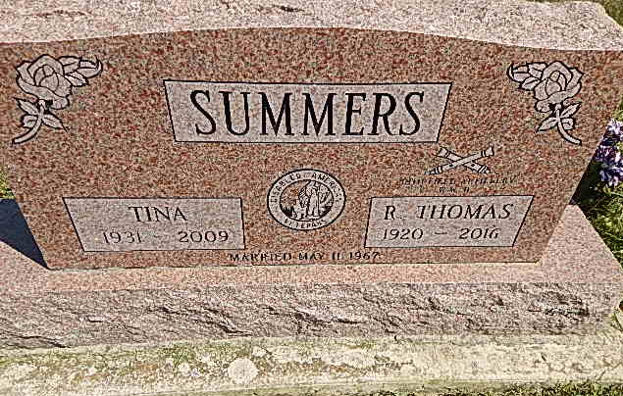
Photo by Alicia Kneuss

Raymond "Tom" Summers, 95 years old of Fort Wayne, Indiana, passed away on Saturday, February 27, 2016 at Parkview Regional Medical Center in Fort Wayne. He was born on Tuesday, September 7, 1920 in Decatur, Indiana the son of the late Lloyd E. Summers and the late Rose (Hoffman) Summers. He married Tina R. Kang on May 11, 1967 in Seoul, Korea and she preceded him in death on November 2, 2009.
Tom was a member of the First Missionary Church in Fort Wayne and the Christian Homemakers Sunday School Class. He was also a charter member of the Disabled American Veterans Post #40 in Fort Wayne. He enjoyed traveling, flea markets, and spending time with family. He was a graduate of Decatur High School in 1939.
Tom entered the United States Army in September of 1939 and served with the 58th Armored Field Artillery during WWII. He participated in the assault landing on Normandy beachhead, where he was wounded. He also participated in the Battle of the Bulge and the remainder of the war. In March of 1943, he was promoted to Master Sergeant (Battalion Sergeant Major). He was the youngest non-commissioned officer that stormed the beach of Normandy. He received seven campaign stars for service in Africa, Sicily and across Europe. His decorations include 2 Bronze Stars, 2 Purple Hearts, 2 awards for the Army Commendation Medal, and the Presidential Unit Citation. After serving several tours of duty in Korea, he retired from the US Army in 1965. Tom was also in the 58th Infantry Reunion Group and attended yearly gatherings in South Carolina until 2009.
Surviving are his sister, Evelyn (Allen) Felt of rural Decatur, IN; sister-in-law, Hazel Summers (widow of James) of Grafton, ND; 11 nieces; 8 nephews; 10 great-nieces; 12 great-nephews; 18 great great-nieces; 30 great great-nephews; 3 great great great-nieces; and 6 great great great-nephews.
Preceding Tom in death were three brothers, Edward (Katie) Summers; Walter (Kate) Summers; and James Summers and three sisters, Dorothy (Bud) Lunn; Martha (Oral) Morris, Mary (Merrill) Johnson.
Funeral services will be held at 12:00 noon on Saturday, March 5, 2016 in the Zwick & Jahn Funeral Home in Decatur with Rev. Stephen Buckner officiating. Interment will follow in the Decatur Cemetery with Military Graveside Services to be conducted by the American Legion Post #43 of Decatur. Friends will be received from 10:00 a.m. to 12 noon on Saturday, March 5, 2016 in the Zwick & Jahn Funeral Home in Decatur.
Preferred memorials are to First Missionary Church in Fort Wayne or Lutheran Military Veterans and Families Ministries, Inc. (LMVFM) in Fort Wayne, Indiana.

Zwick & Jahn Funeral Home, Adams County, Indiana
March 1, 2016

