Luella (Shepard) Summers
August 16, 1860 – December 30, 1929

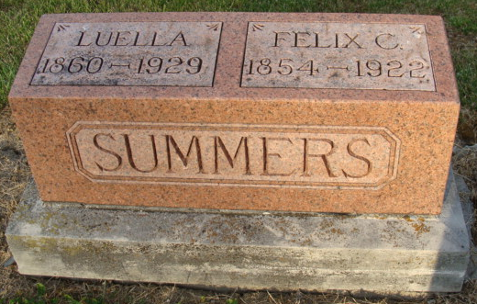
Photo by Alicia Kneuss

Mrs Luella Summers
in the Indiana, U.S., Death Certificates, 1899-2017

Name Mrs Luella Summers
[Mrs Luella Shepperd]
Maiden Name Shepperd
Gender Female
Race White
Marital Status Widowed
Age 69
Birth Date 16 Aug 1860
Birth Place Ohio
Death Date 30 Dec 1929
Death Place Washington, Adams, Indiana, USA
Death Registration Date 1929
Father John A Shepperd
Mother Angeline Pense
Spouse Phil F. Summers
Informant None listed
Burial January 2, 1929 [sic]; Maplewood Cemetery

