Lloyd E. Summers
June 4, 1880 – September 2, 1941

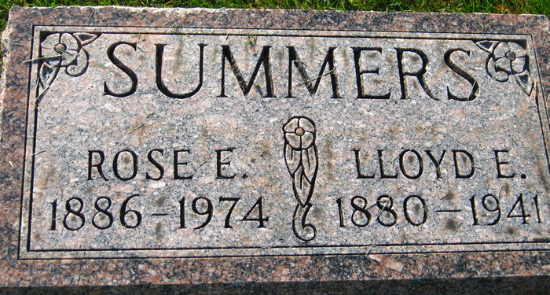
Photos by S Riley

FUNERAL RITES FOR WATCHMAN
Services Held Today For L.E. Summers, Retired Railroad Employee

Funeral services were held this afternoon at 2 o’clock at the Zwick funeral home for Lloyd E. “Zeke” Summers, 61, retired Pennsylvania railroad crossing watchman, who died Sunday morning at the Adams county memorial hospital of cerebral hemorrhage. Burial was made in the Decatur cemetery.
He had been employed by the Pennsylvania railroad for 40 years, serving first as a pump station operator and for a number of years as watchman at the Monroe street crossing. He was born near Poe on June 4, 1880, but had resided in this city most of his life.
Surviving, besides the widow, are four daughters, Mrs. Dorothy Lunn and Mrs. Malinda Lewis, both of Fort Wayne, Mrs. Mary Neuenschwander of Paw Paw, Michigan and Evelyn at home; four sons, Edward Summers of Fort Wayne, Walter, in the army at Camp Walters, Texas; R. Thomas in the army at Fort Knox, Kentucky and James of Wabash; two sisters, Mrs. Emma Simmerman of Decatur and Mrs. Edith Henry of Ossian. One sister is deceased.
He was a member of the Methodist church here. Rev. R. W. Graham and Rev. Charles M. Prugh officiated at the services.

Adams County, Indiana Historical Museum
1941b Jan-Dec Scrapbook, Image 89
Handwritten-Tuesday, Sept. 2, 1941
**

Indiana, U.S., Death Certificates, 1899-2011
Name: Lloyd E Summers
Gender: Male
Race: White
Age: 61
Marital status: Married
Birth Date: 4 June 1880
Birth Place: Near Poe Indiana
Death Date: 31 Aug 1941
Death Place: Decatur, Adams, Indiana, USA
Father: David Summers
Mother: Martha Davidson
Spouse: Rose Hoffman
Informant: Mrs. L. E. Summers; Decatur, Indiana
Burial: September 2, 1941; Decatur Cemetery; Decatur, Indiana

